Tues. April 3 | Practice: 3:00 – 4:30
Friday, April 6 | Practice after school until high school bus. (12:00 – 2:30.) LUNCH NEEDED.
Mon. April 9 | Practice: 3:00 – 4:30 Costumed.
Tues. April 10 | Practice: 3:00 – 4:30
Wed. April 11 | OEC Drama Festival  Perform at 2:00 at OHS
Thurs. April 12 | CNCS Evening Performance  at 7:15. Students are to be in the Gr. 1 room at 6:45.
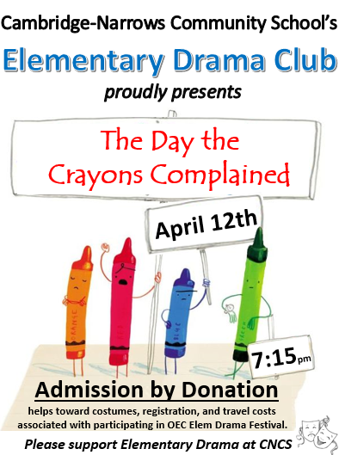

March 23, 2018
Dear Elementary Drama Family,
I have two very important items I need feedback on:
- TRANSPORTATION: The elementary drama club works on a shoestring budget since the only money the club earns is from what is donated at the door on the evening of the performance for the community. There is a $100 registration fee required to participate in the elementary drama festival and the cost of the bus to transport us there adds significantly to that. We only get the bus to transport us THERE and not back since most parents do attend the awards presentation at the end of day and come for the performance. I have reserved a bus for April 11th to take us to the festival. My HOPE is that we can get by WITHOUT a bus if a number of you and/or other family members were planning on attending the festival on that day anyway. The festival this year is taking place over a 3 day period, and on Wednesday (our day): there are only 3 schools performing and ALL performances are in the afternoon. So, my question is this:
On April 11^{th:} would you be able to transport your child to Oromocto High School for approximately 12:00? The second part is: would you be willing to transport other students? If so; how many? Please keep in mind: to transport OTHER students you require 2 million dollars liability on your insurance AND winter tires.
- COSTUMES: Those students who are crayons in the play are to wear dark pants (plain black or navy leggings/jeans/pants) with a plain t-shirt the color of the crayon. Example: Green Crayon wears a plain green t-shirt. Crayons will also have a matching crayon tip/hat that will be made at school. So, my question is this:
Will you accept the responsibility to find a t-shirt the color needed for your child and get it to me on or before Friday, April 6th? A t-shirt can be worn inside out in order to make it plain and it certainly does not need to be new. There are a few crayons which require costumes and I will have added an extra note if this applies to your child.
With appreciation,
Ms. Wilson
PLEASE complete and return the following short questionnaire by THURSDAY so that I can plan accordingly. THANKS!
******************************************************************************
I can transport my child to Oromocto High School for 12:00 on April 11th. ____YES or ____ NO
I can pick my child up from Oromocto High School at approximately 4:30 ____YES or ____NO
I can take more students with me in my vehicle and have the insurance coverage and winter tires as outlined above. _____YES _____NO
If yes: I have room to take _____ additional child(ren) to Oromocto High School. I have room to bring ______additional child(ren) back to CNCS after the festival.
COSTUMES: I will find my child a plain t-shirt matching the color of their crayon and have it at the school by Friday April 6th. If my child is more than one crayon in the play I will find all the necessary t-shirts. _____YES ______NO
PARENT SIGNATURE: ________________________________________

